Sommario
SAMPLE AND FORMAT FOR THE REQUEST 1
REQUESTS LIST 3
Owners – Restricted Content Changes 4

SAMPLE AND FORMAT FOR THE REQUEST

(COUNTRY)
(URL WEBSITE)
(REASON WHY)
(DESCRIBE YOUR REQUEST HERE)
(TIMING)
(SCREENSHOT)

ITALY
https://it.pli-petronas.com/it/marche/petronas-syntium
https://it.pli-petronas.com/it/products/petronas-syntium
https://it.pli-petronas.com/it/officine/auto
We have need related to our business\market.
We would like to add\change\modify to get properly this goal.
We need to add this component.
Add this video
Change this paragraph
Content to enrich this part
We have a launch\activities\ on this day, so we would love to understand if we can get this by XXX
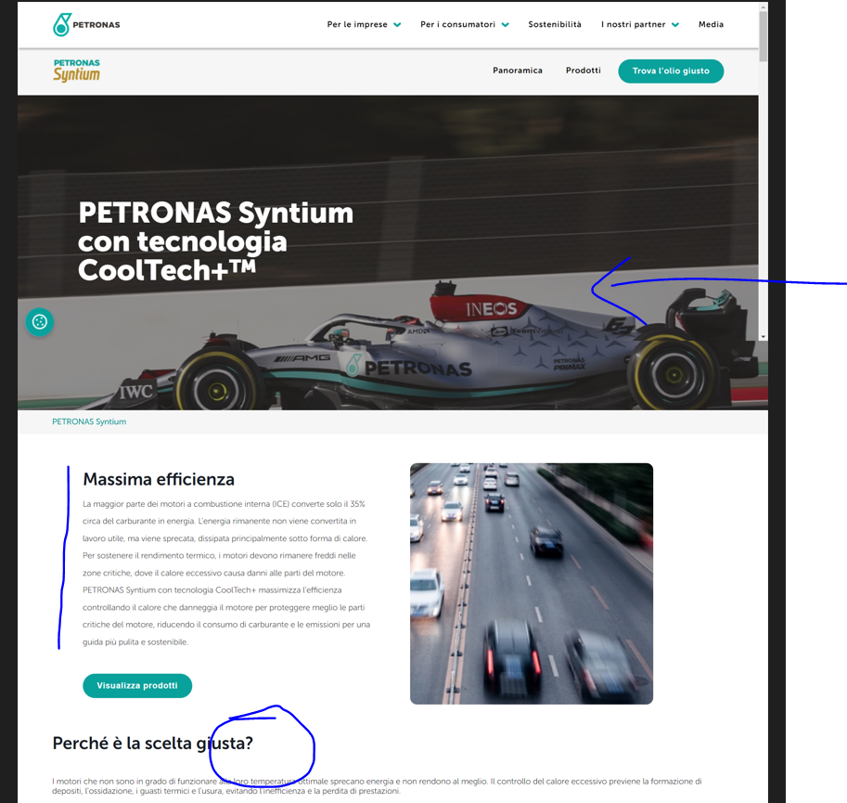

REQUESTS LIST

(COUNTRY)
(URL WEBSITE)
(REASON WHY)
(DESCRIBE YOUR REQUEST HERE)
(TIMING)
(SCREENSHOT)

(COUNTRY)
(URL WEBSITE)
(REASON WHY)
(DESCRIBE YOUR REQUEST HERE)
(TIMING)
(SCREENSHOT)

Owners – Restricted Content Changes

PRODUCT | BRAND OWNER | CC
Syntium | Marco Cragno | Samantha Burello, Jacques Chemidlin
Sprinta | Marco Cragno | Samantha Burello, Jacques Chemidlin
Urania | Ivy Yeoh | Samantha Burello, Luca Di Stefano
Arbor | Samantha Burello | Samantha Burello, Jacques Chemidlin
Tutela | Ivy Yeoh | Samantha Burello, Luca Di Stefano
Selenia | Marco Cragno | Samantha Burello, Jacques Chemidlin
Durance | Samantha Burello | Jame Mark, Jacques Chemidlin
Business solutions / sectors | Samantha Burello | Ian Gan / Andrew Holmes
Industrial | Achilleas Kortozos | Andrew Holmes, Muthu Amaranathan
Distributors | Silvano Berardo | Regional CX lead
Workshops | Dimitri Pavlovskyy | Chun Chung Wong
OEM partners | James Mark | Achilleas Kortrozos

+ always Youri and Arvin and pli-team@havas.com in CC

